**EQLMS GRAPHICAL USER INTERFACE DESIGN DOCUMENT**

**Introduction**

* Since our website is for Kinder 1 to Grade 6, my team decided that our website will be designed for children. The color will be good for them and it will be easy for the children to understand the flow of our website.

**EQLMS GUI**

**Log in page (Admin/Teacher/Student)**

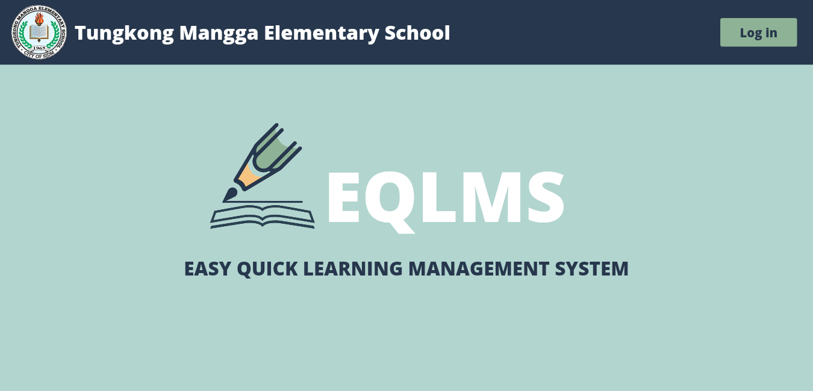

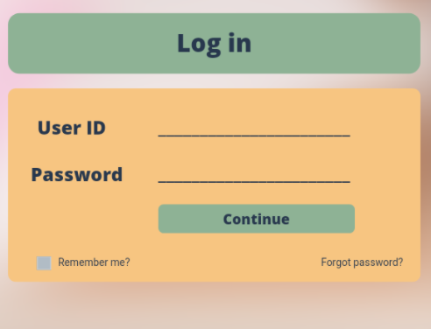

**Purpose:** Starting page.  
Page contains:

* Basic information and objectives with corresponding images that slides
* Log in form

**Navigation & UI:** User can enter their account credentials for them to log their accounts. If the log in attempt is successful, it will lead the user to EQLMS home page (Admin/Teacher/Student)

**Account Page (Admin/Teacher/Student)**

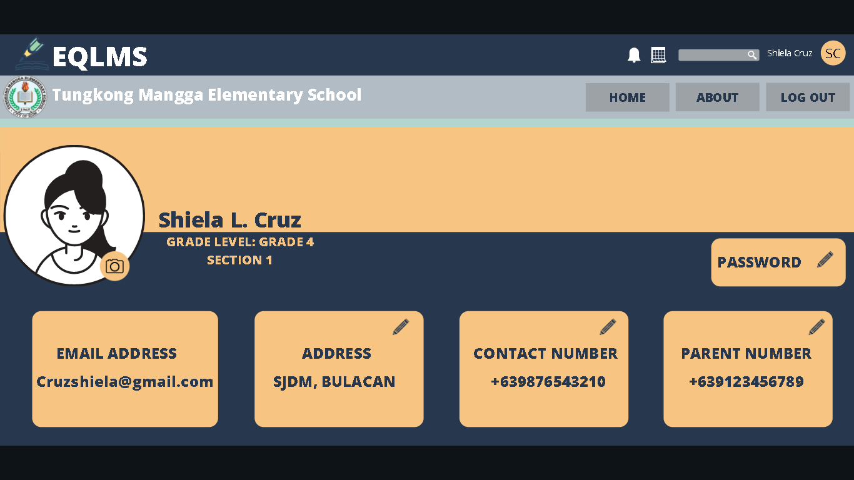

**Purpose:** In this page, the 3 Users can see their corresponding account details.

**Navigation & UI:** The Admin, Teacher, and student user can change the corresponding details in their account and save it.

Functions:

* Change password, address, Contact number, parent contact number, and profile picture

Navigation:

* Home page
* About page
* Schedule page

**About Page (Teacher/Student)**

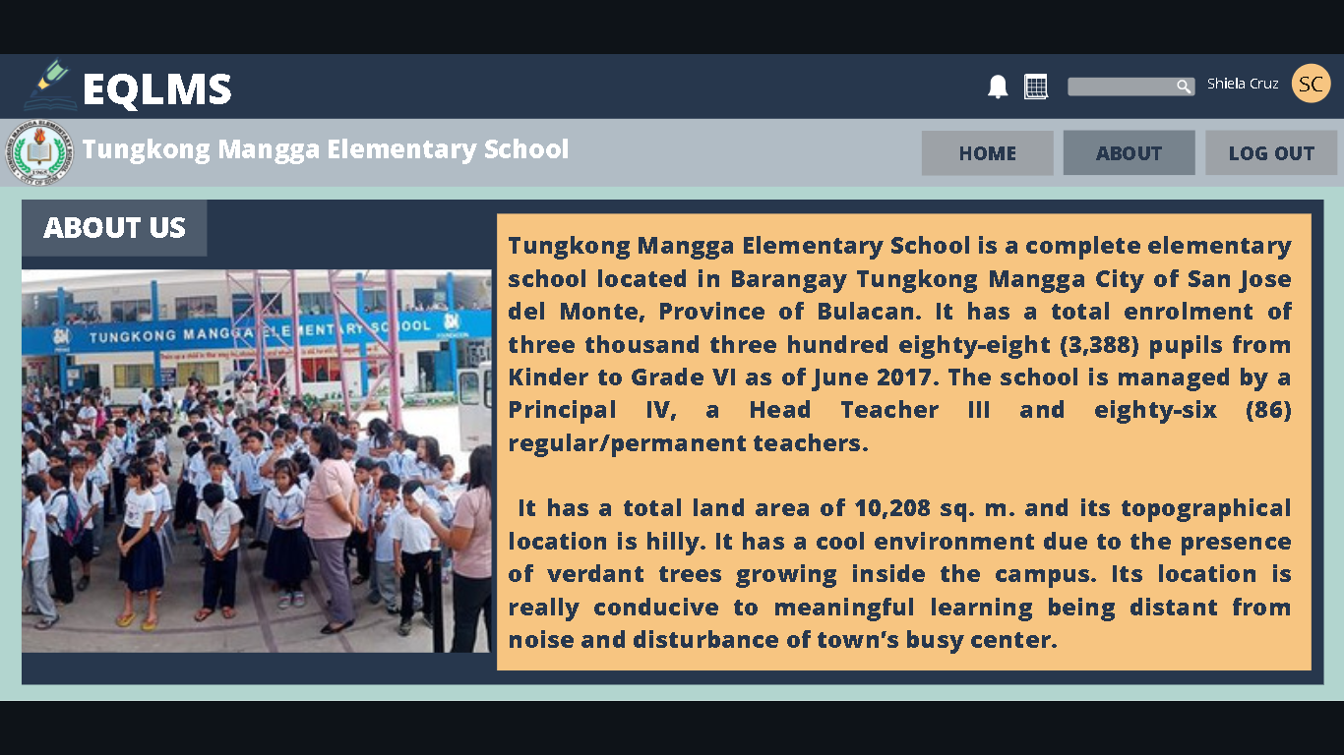

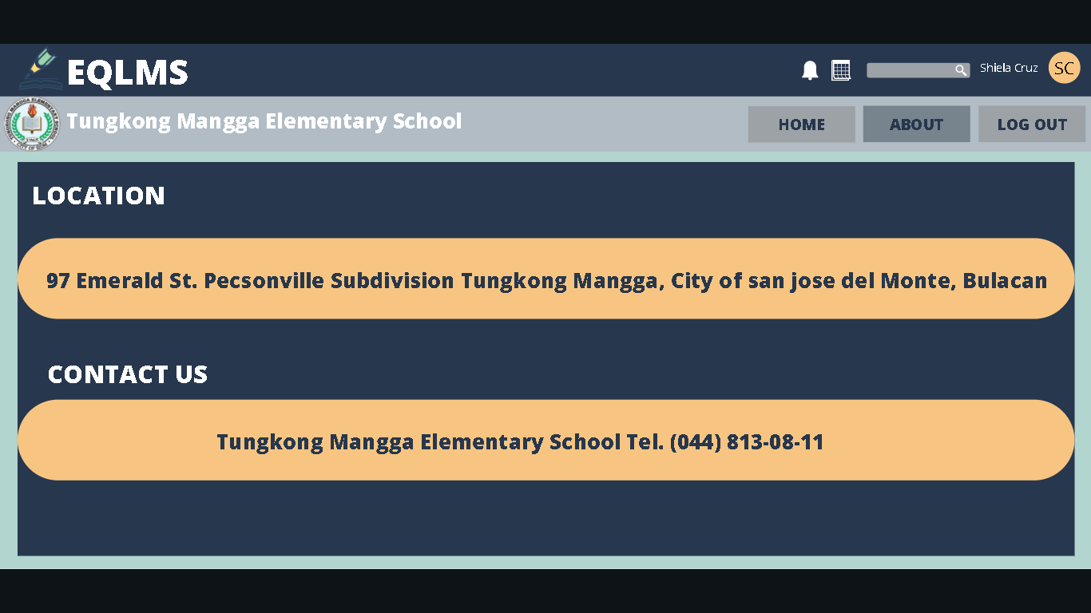

**Purpose:** In this page, Student and Teacher users can see the details about the Tungkong Mangga Elementary School

**Navigation & UI:** User can lead to:

* Home page
* Account page
* Schedule page

**Schedule Page (Admin/Teacher)**

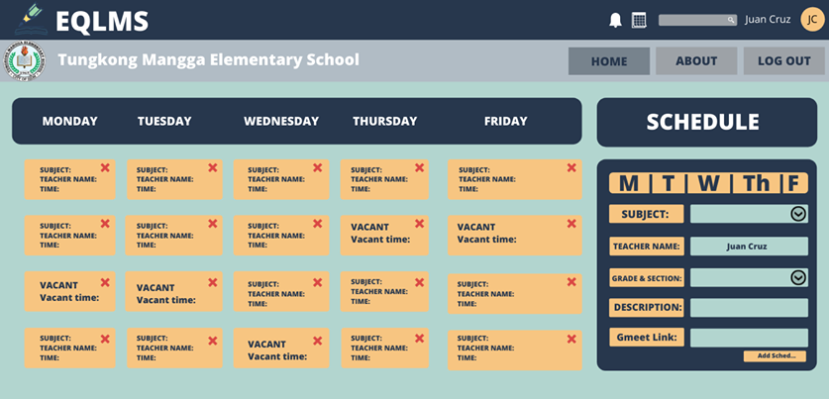

**Purpose:** In this page, schedule can be posted or seen by teacher and Admin. the Teacher and Admin user can also create a schedule for a specific group (teacher meeting/ class schedule).

**Navigation & UI:** Admin and Teacher users can add schedule for a specific grade level and section by clicking the Add schedule button which leads the user to the pop-up division of add schedule.

Function:

* Add schedule
* Remove schedule
* Add schedule
* Add a teacher’s meeting and orientations (Admin)
* Add a class schedule (Teacher)

**Schedule Page (Student)**

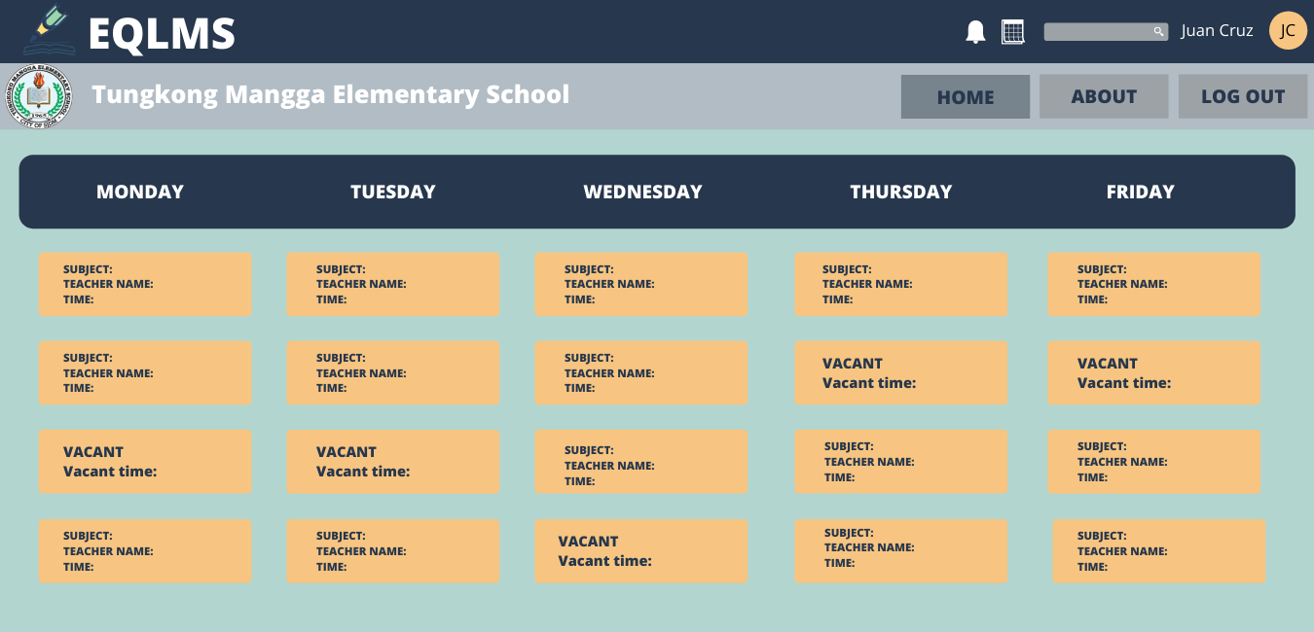

**Purpose:** Student can see their corresponding class schedule

**Navigation & UI:** If student clicked the link in a schedule, the student will be redirected to the specific Gmeet link. The student user might be redirected to:

* Home page (Student)
* About page (student)
* Schedule page
* Gmeet link
* Account page

**Admin UI**

**Home Page (Principal)**

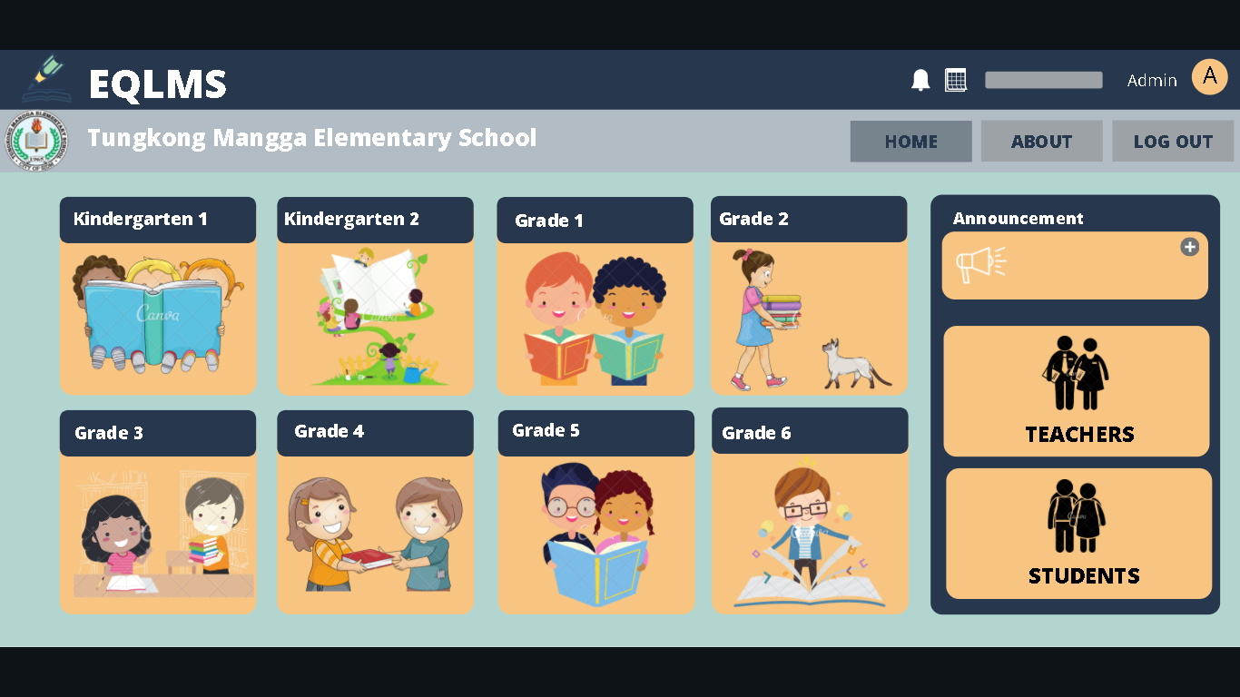

**Purpose:** Home page of the Admin Users

Page contains:

* Various buttons that lead the admin to another page.

**Navigation & UI:** The Admin user can click any of the buttons that will lead the admin users to:

* Specific Grade Level
* Teacher Accounts Division (pop up division)
* Student Accounts Division (pop up division)
* Announcement Division (pop up division)
* About page (admin)
* Account page
* Schedule page

**Grade level Page**

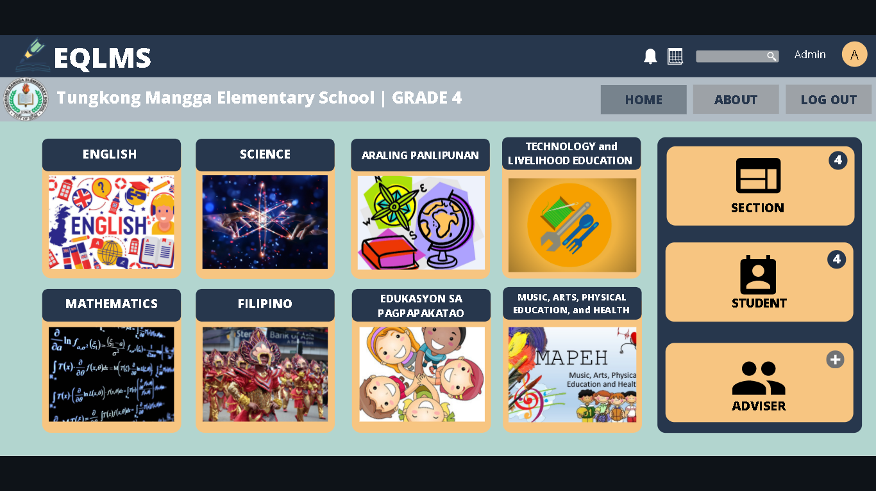

**Purpose:** Subject section in a specific Grade level

Page contains:

* Various buttons that lead the admin to another page.

**Navigation & UI:** The Admin user can click any of the buttons that will lead the admin user to:

* Specific Subject for the specific grade level
* Sections Division (pop up division)
* Student Division (pop up division)
* Adviser Division (pop up division)
* About page (admin)
* Account page
* Schedule page

**Add Section division (Pop ups)**

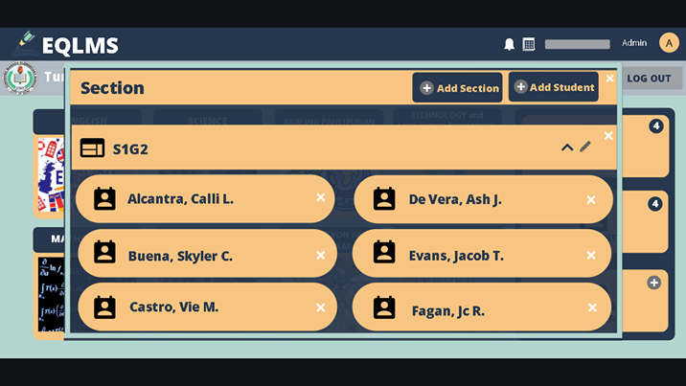

**Purpose:** A pop up division where sections of the specific grade level can be seen.

**Navigation & UI:** Admin can add and rename a section and also add a student to corresponding sections. If the add student button is clicked, the add_student_to_section_division will pop up.

Functions:

* Add section/s
* Name/rename Section/s
* Delete Section/s

**Add student to section division (Pop ups)**

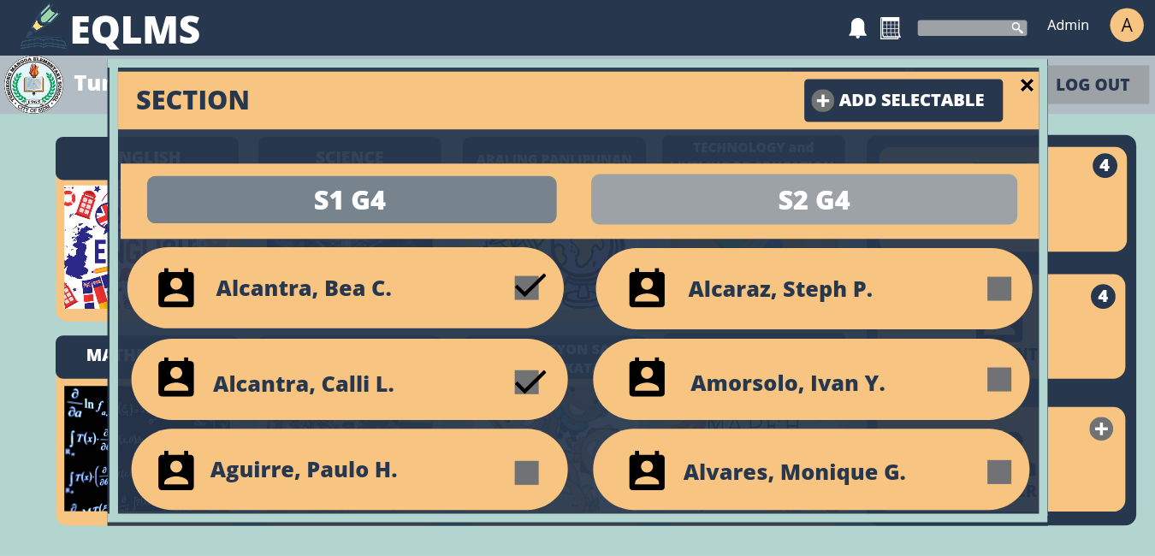

**Purpose:** Pop up division where students in a specific grade level can also be seen.

**Navigation & UI:** Admin can select students from a specific grade level and then add it to a specific section.

Function:

* Select student/s
* Add student/s to a specific section

**Add Adviser to section division (Pop ups)**

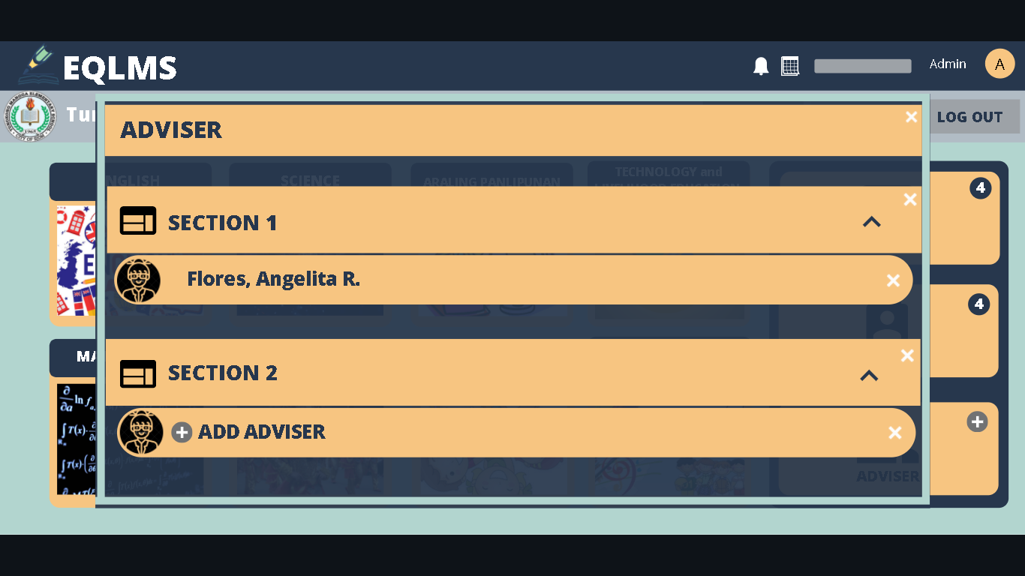

**Purpose:** Admin can assign adviser to a specific grade level and section

**Navigation & UI:** Admin can assign an teacher to be a adviser for a specific section.

**Add teacher to subjects division (Pop ups)**

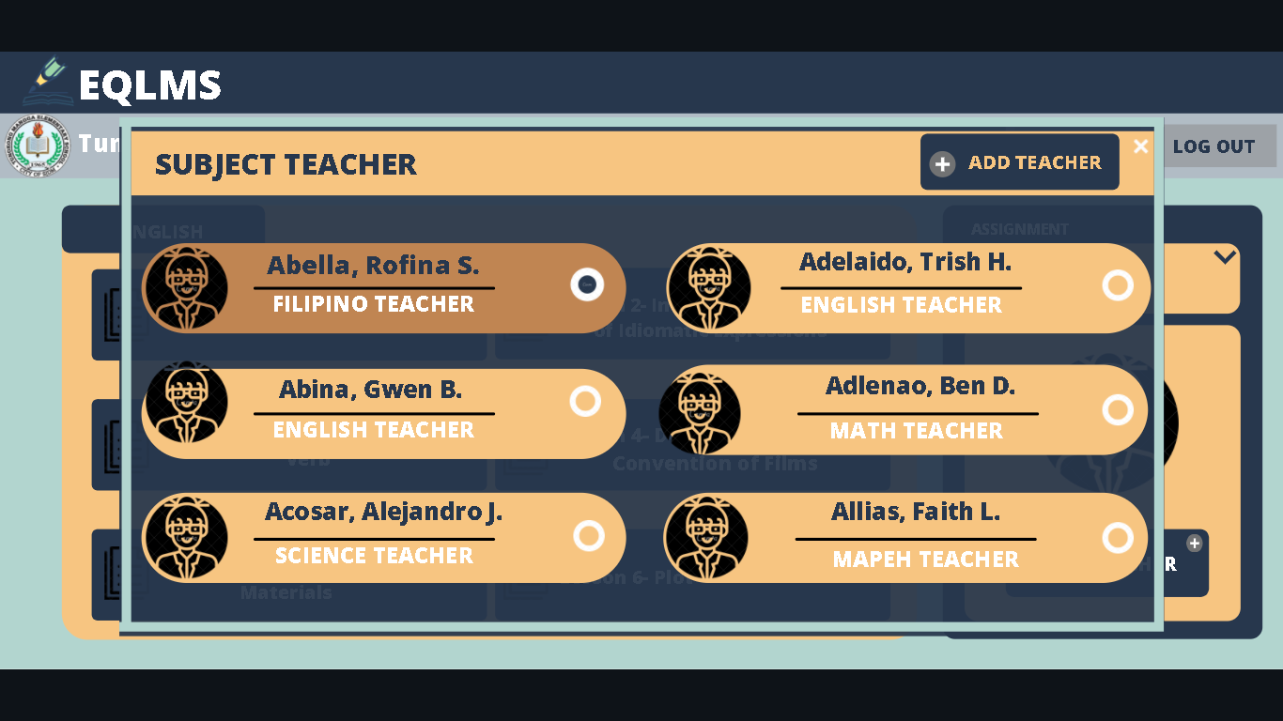

**Purpose:** Pop up division where teacher is assigned to a specific subject in a specific grade level and section

**Navigation & UI:** Admin user can select 1 teacher to be assigned to the specific subject

Functions:

* Select teacher
* Add teacher

**Module page (Admin)**

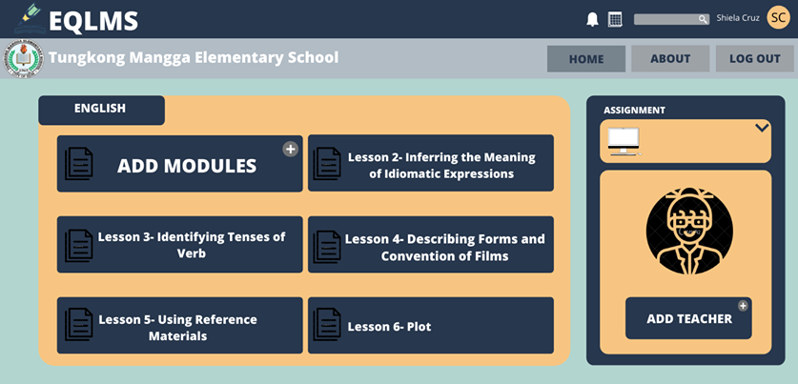

**Purpose:** The added modules by the admin can be seen in this page

**Navigation and UI:** Admin can select the add modules and teacher for this page.

**Add Modules to Subjects division (Pop ups)**

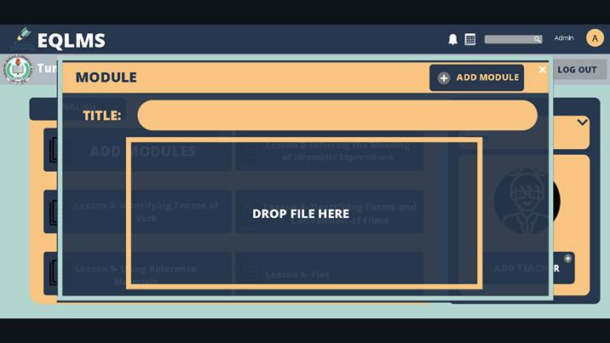

**Purpose:** Admin can add modules in the specific grade level and subject

**Navigation & UI:** Admin users can add a title of the module and drop a pdf file of the module.

Functions:

* Add title of the module
* Drop file of the module
* Save and post the module

**About Page(admin)**

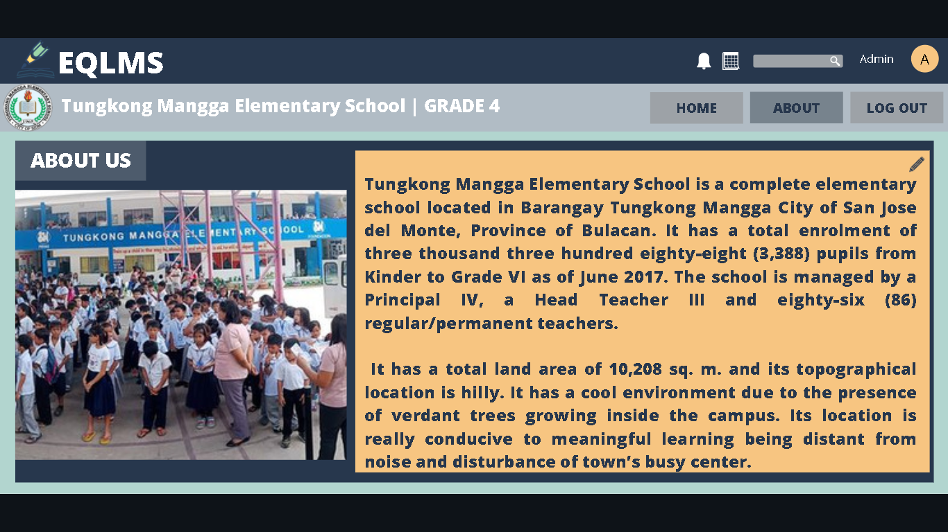

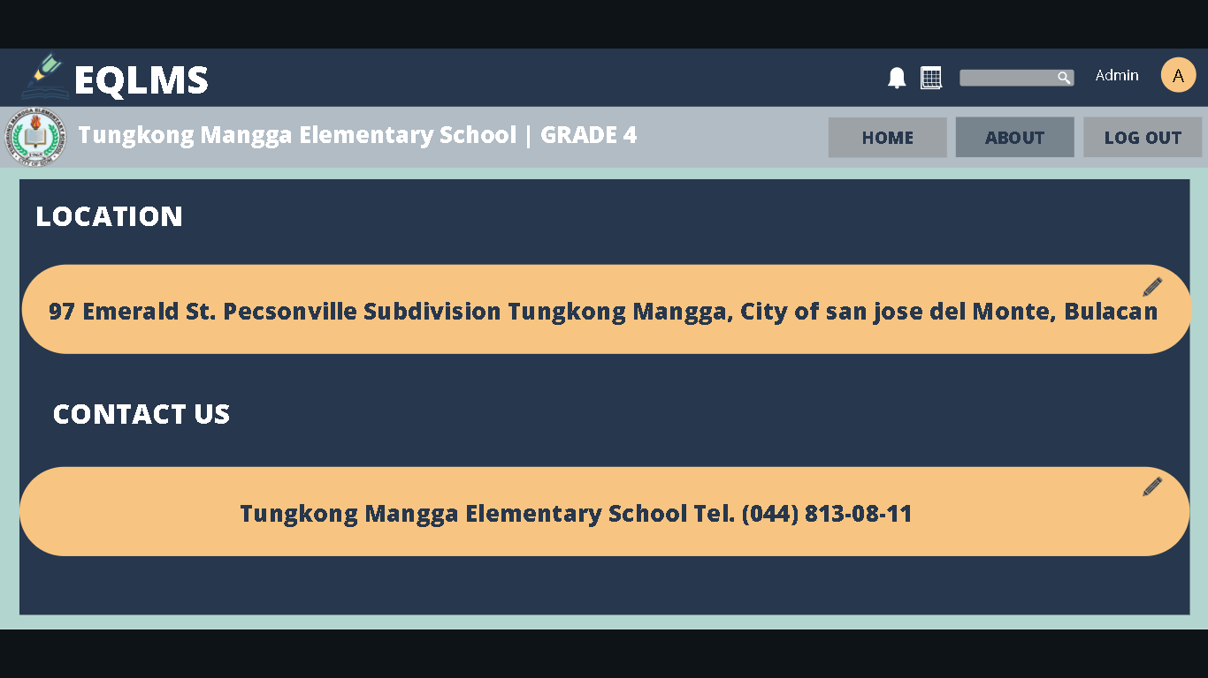

**Purpose:** This page displays the basic information of the TMES

**Navigation & UI:** Admin users can edit the corresponding information.

Functions:

* Edit specific information
* Save and update the edited information

Navigation:

* Home page (Admin)
* About page (Admin)
* Schedule page (admin / teacher)
* Account page
* Notifications

**Teacher UI**

**Home Page (teacher)**

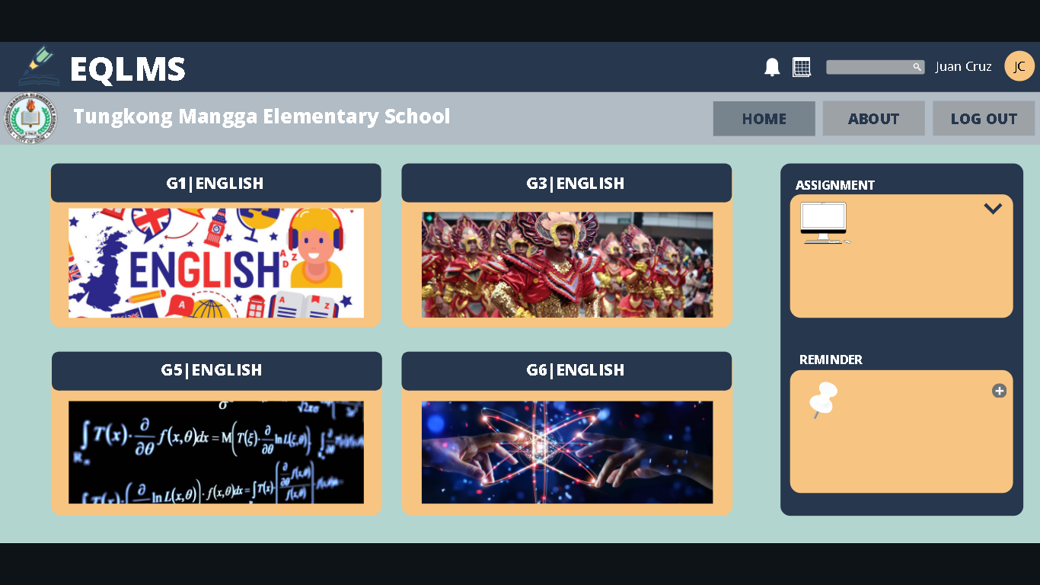

**Purpose:** Home page of the Teacher/s

**Navigation & UI:** Teacher users can click any of the buttons that will lead the Teacher user/s to:

* Specific assigned subject/s
* Given assignments
* About(teacher/student)
* Schedule page(admin/teacher)
* Notifications
* Add announcement(students)

**Module Page(teacher)**

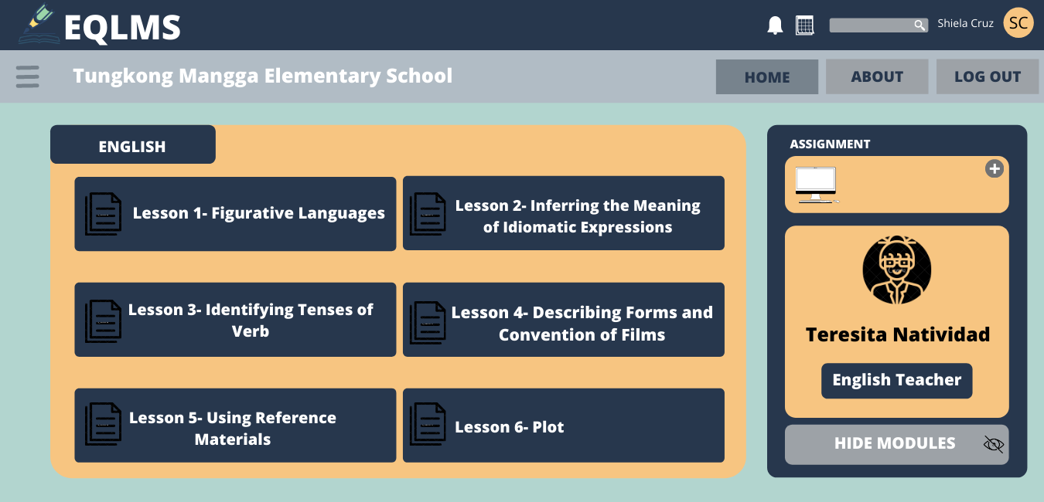

**Purpose:** Page where modules are posted by the admins and hidden from all students.

**Navigation & UI:** Teacher users can show or hide modules and add assignments.

Functions:

* Add assignment or quiz
* Hide/show modules

Navigation:

* Home page (Teacher)
* About page (teacher / student)
* Schedule page (admin / teacher)
* Account Page

**Add Quiz/Assignment dropbox division (pop ups)**

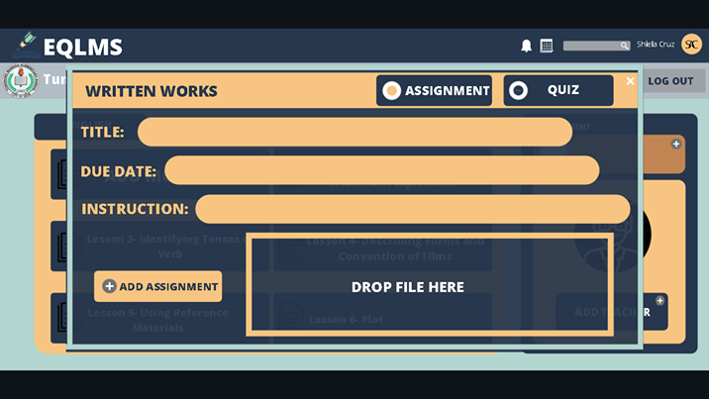

**Purpose:** In this pop-up division, here are the written works for students are posted.

**Navigation & UI:** Teacher users can make an assignment or quiz with a corresponding information about the specific written work and post it.

Functions:

* Add assignment/quiz title
* Add due date
* Add Instruction
* Drop a pdf file of an assignment or quiz
* Select quiz or assignment

**Student UI**

**Home Page (student)**

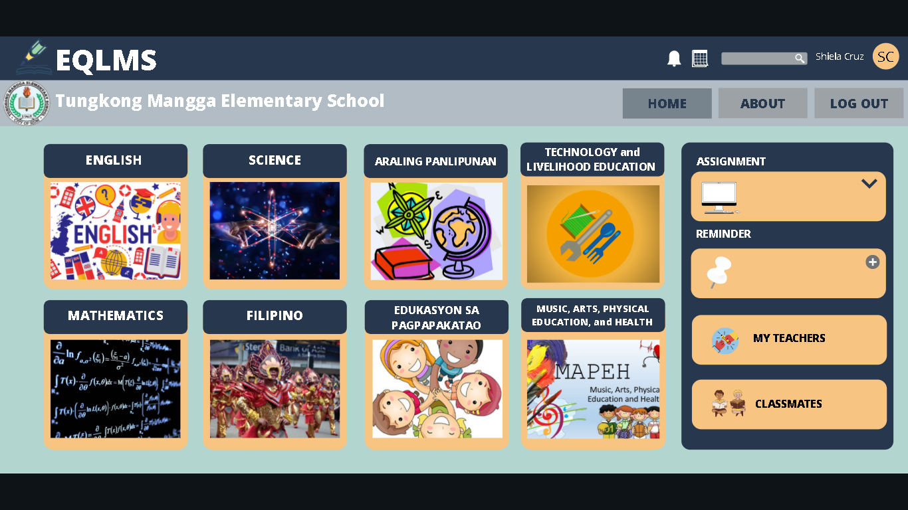

**Purpose:** Home page of Student User/s

**Navigation & UI:** Student Users can go to the specific page:

* Subject page
* Assignment dropbox page
* About page
* Schedule page
* Account page

**Module Page(student)**

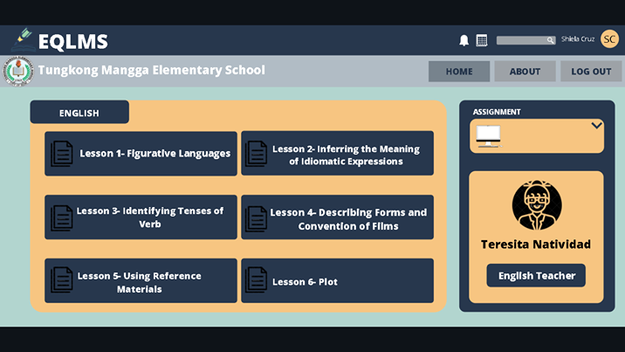

**Purpose:** Page where modules can be seen and downloaded

**Navigation & UI:** student can check their assignments or quizzes and download modules.

**Assignment Dropbox**

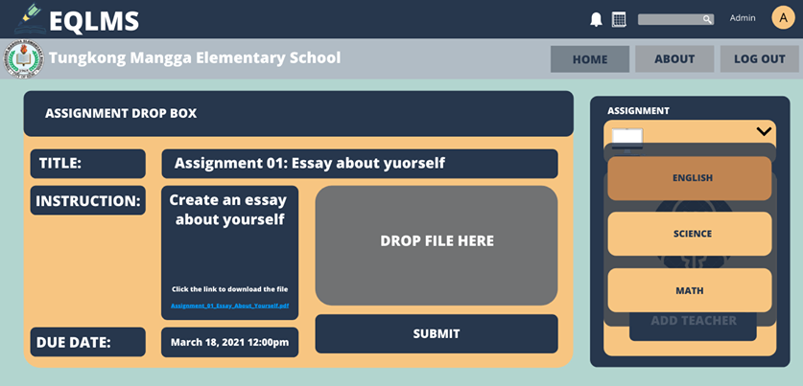

**Purpose:** This is where assignments or quizzes are passed

**Navigation & UI:** Student can pass their quiz or assignment by putting it on the drop box.